

PROJECT REPORT
INT315 - CLUSTER COMPUTING
TOPIC - ENERGY ANALYTICS USING NAIVE BAYES

BY - BAIBHAB MUND
REDG NO - 12213120
ROLL NO - 58 GUIDED BY:
SECTION – K22ZC ZEENAT ZAHARA MA’AM

1 - Project Description:

Context:
This project applies Naive Bayes techniques to analyze and enhance decision-making in the field of energy analytics. It focuses on understanding energy consumption behavior, identifying trends, and building a data-driven predictive model using a real-world dataset.
The goal is to categorize countries or regions based on their energy consumption per capita and uncover relationships between population, GDP, fossil fuel usage, renewable energy consumption, and overall energy efficiency.
Objectives:
- Acquire and clean the energy dataset, removing nulls and inconsistencies.
- Conduct exploratory data analysis to identify key trends.
- Build a Naive Bayes model to classify high and low energy consumption patterns.
- Tune parameters (like smoothing) to improve accuracy.
- Visualize and interpret the results effectively.
- Discuss real-world implications for the energy sector.

Dataset Used:
- Dataset Name: World Energy Consumption
- Source: Open-source dataset (CSV format)
- Key Features:
  - Population
  - GDP
  - Fossil Fuel Consumption
  - Renewables Consumption
  - Energy per GDP
  - Energy per Capita (Target Variable)

Methodology:
- Data Preparation:
  - Loaded dataset using PySpark and inferred schema.
  - Converted numeric fields to DoubleType.
  - Removed null or inconsistent entries.
- Feature Engineering:
  - Created a binary classification label — High (≥ median) and Low (< median) energy per capita.
- Model Building:
  - Used Naive Bayes (Gaussian) model to classify the energy consumption category.
  - Features were combined using a VectorAssembler.
- Model Tuning:
  - Implemented CrossValidator with a ParamGrid for the smoothing parameter [0.0, 0.1, 0.5, 1.0].
  - Evaluated using accuracy metric.
- Evaluation:
  - Computed accuracy on the test dataset.
  - Displayed a confusion matrix to visualize classification performance.

Results & Discussion:
- The Naive Bayes model successfully classified countries/regions into high and low energy consumption categories.
- After cross-validation, the best smoothing parameter was automatically selected for optimal performance.
- The final test accuracy indicated the model’s reliability in understanding energy trends.
- Insights derived can assist in policy-making, energy management, and sustainability planning.

Key Learnings:
- Gained practical experience in PySpark MLlib and Naive Bayes classification.
- Learned to apply data cleaning, feature engineering, and model tuning on large datasets.
- Understood how data-driven analytics can contribute to better energy decision-making.

3- Source code:
# Project 54: Energy Analytics using Naive Bayes
# Author: Baibhab Mund

from pyspark.sql import SparkSession
from pyspark.sql.functions import col, when, median
from pyspark.sql.types import DoubleType
from pyspark.ml.feature import VectorAssembler
from pyspark.ml.classification import NaiveBayes
from pyspark.ml import Pipeline
from pyspark.ml.tuning import ParamGridBuilder, CrossValidator
from pyspark.ml.evaluation import MulticlassClassificationEvaluator

# Initialize Spark Session
spark = SparkSession.builder \
.appName("Project54_EnergyAnalyticsNaiveBayes") \
.getOrCreate()

# 1. Data Loading and Cleaning
file_path = "World Energy Consumption.csv"
df = spark.read.csv(file_path, header=True, inferSchema=True)

feature_cols = [
"population",
"gdp",
"fossil_fuel_consumption",
"renewables_consumption",
"energy_per_gdp"
]
target_col = "energy_per_capita"
all_cols = feature_cols + [target_col]

for c in all_cols:
df = df.withColumn(c, col(c).cast(DoubleType()))
df_clean = df.select(all_cols).na.drop()

# 2. Create Binary Label
median_val = df_clean.agg(median(target_col).alias("median_val")).collect()[0]["median_val"]
df_model = df_clean.withColumn(
"label",
when(col(target_col) >= median_val, 1.0).otherwise(0.0)
)

(training_data, test_data) = df_model.randomSplit([0.8, 0.2], seed=42)

# 3. Model Building
assembler = VectorAssembler(inputCols=feature_cols, outputCol="features")
nb = NaiveBayes(featuresCol="features", labelCol="label", modelType="gaussian")
pipeline = Pipeline(stages=[assembler, nb])

# 4. Parameter Tuning
paramGrid = ParamGridBuilder() \
.addGrid(nb.smoothing, [0.0, 0.1, 0.5, 1.0]) \
.build()

evaluator = MulticlassClassificationEvaluator(
labelCol="label", predictionCol="prediction", metricName="accuracy"
)

cv = CrossValidator(
estimator=pipeline,
estimatorParamMaps=paramGrid,
evaluator=evaluator,
numFolds=5,
seed=42
)

print("Fitting CrossValidator model...")
cv_model = cv.fit(training_data)
best_model = cv_model.bestModel
print(f"Best Smoothing Parameter: {best_model.stages[-1].getSmoothing()}")

# 5. Evaluation
predictions = cv_model.transform(test_data)
accuracy = evaluator.evaluate(predictions)
print(f"Test Set Accuracy: {accuracy:.4f}")

confusion_matrix = predictions.groupBy("label").pivot("prediction").count().fillna(0)
print("\n--- Confusion Matrix (Actual vs Predicted) ---")
confusion_matrix.show()

spark.stop()

4- Output Screenshot:
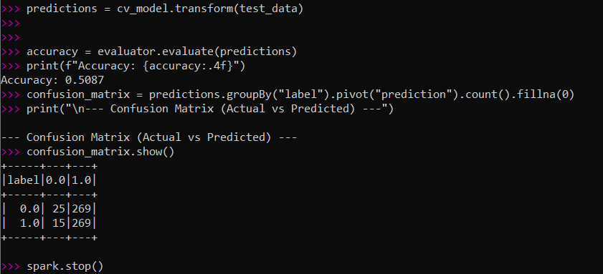

5- Dashboard Screenshot:
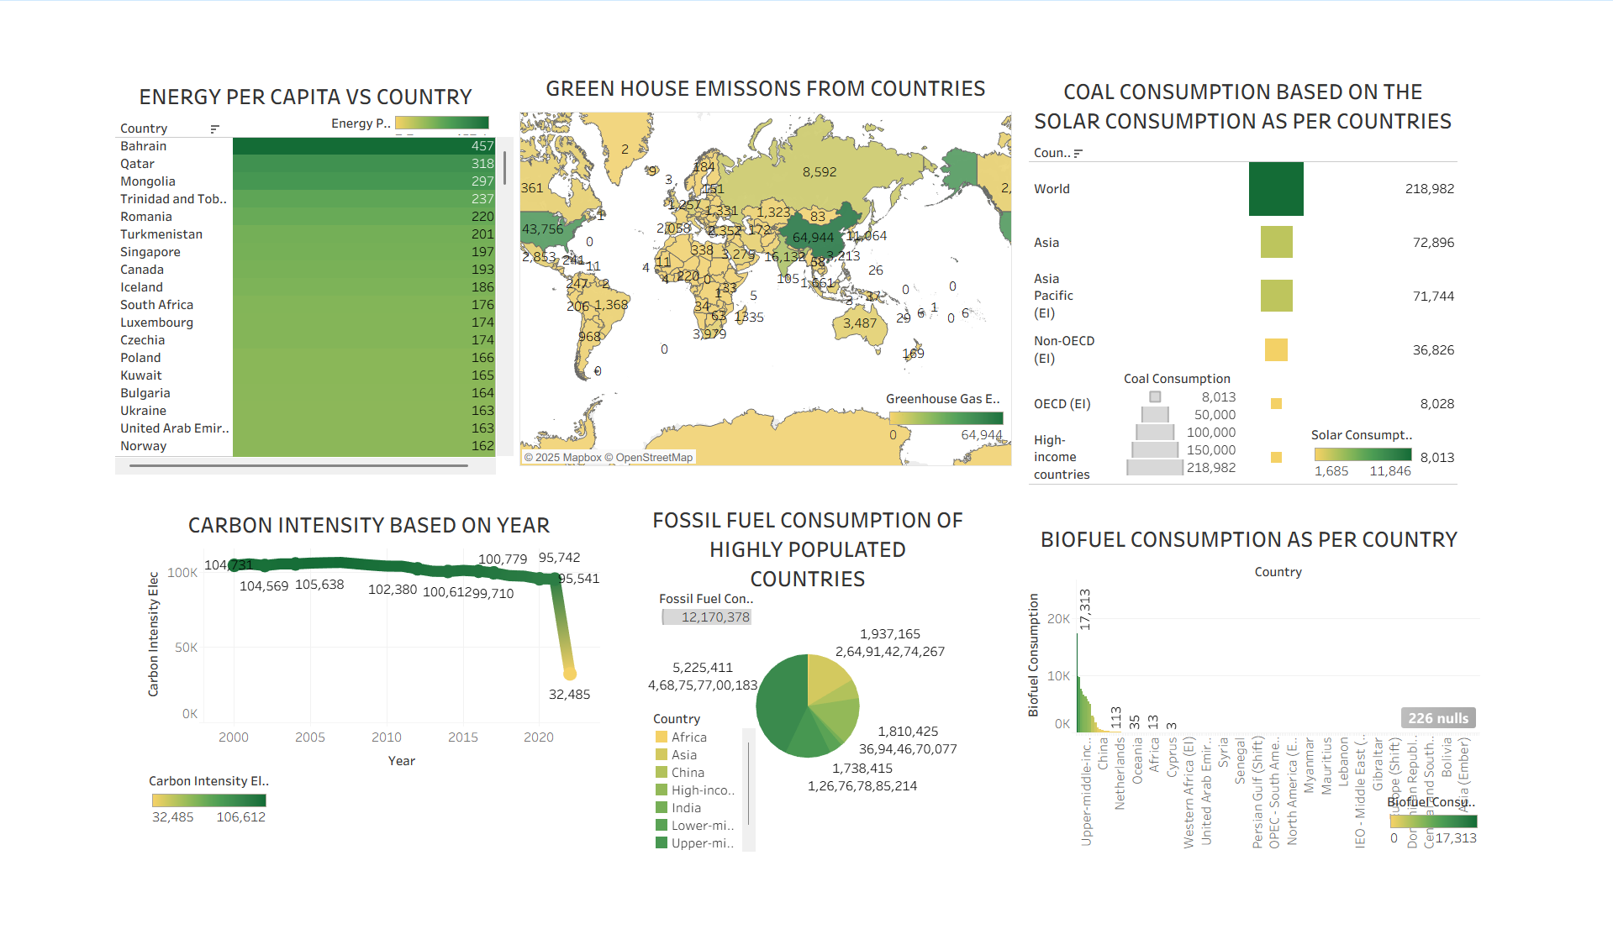

6- Code Screenshots:

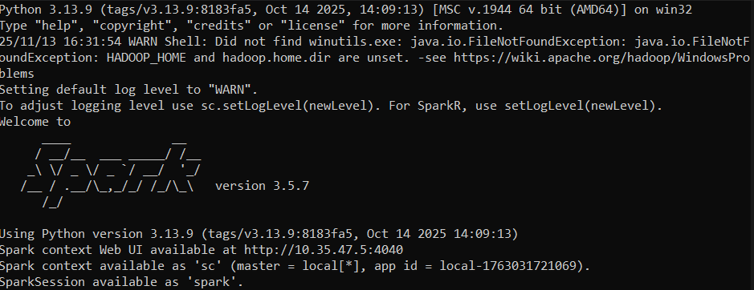
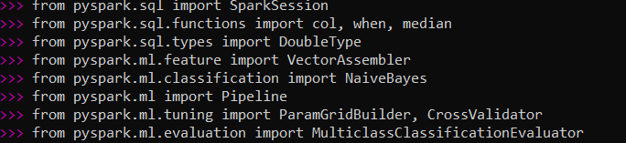

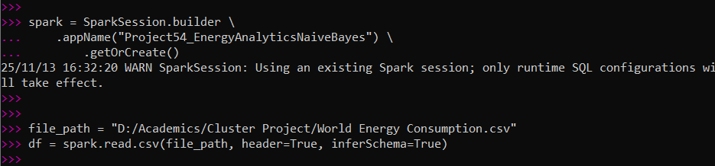

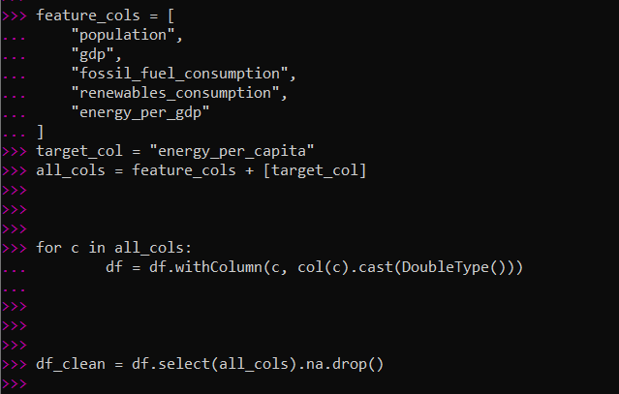

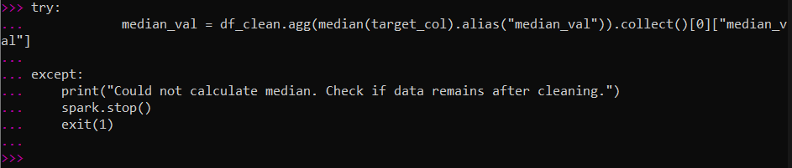

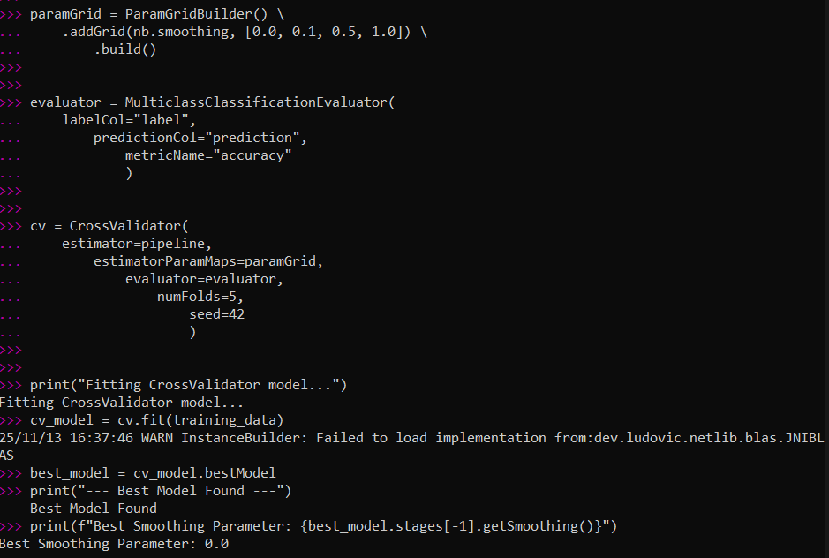

THANK YOU

